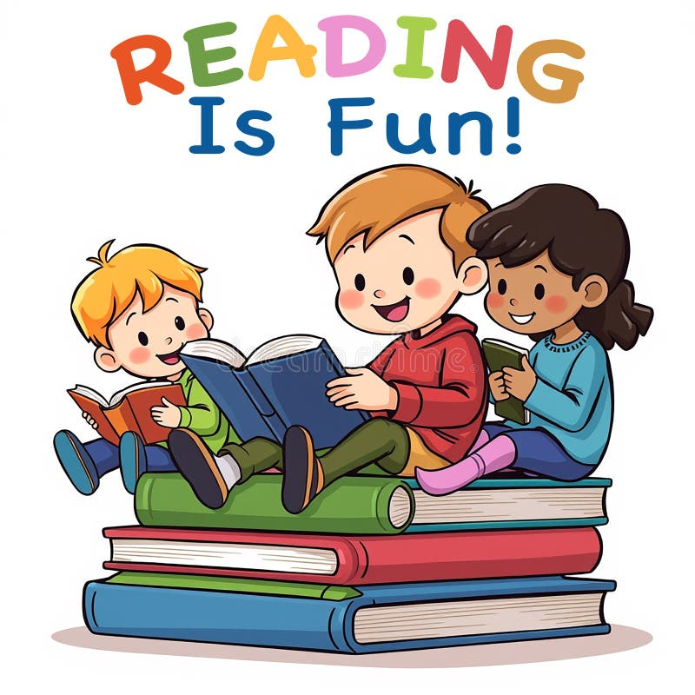
Elwood Carnegie Library Presents
LEARN ABOUT DINOSAURS
Summer Reading Program
Grades k-5
Every Friday starting June 12th-JULY 24TH
6PM – 7PM
COME SIGN UP AT THE LIBRARY BY JUNE 5TH
BRING A FRIEND FOR MORE FUN

